LAB QUESTIONS

Q1. Write a C++ program to create a base class Person with attributes name and age. Derive aclass Student that adds rollNo. Use constructors to initialize all attributes. Create objects of both classes and display their details to show how Student inherits Person members.
#include<iostream>
using namespace std;
class Person{
protected:
string name;
int age;
public:
Person(string n, int a):name(n),age(a){}
void display() const {
cout << "Name: " << name << ", Age: " << age << endl;
}};
class Student : public Person {
private:
int roll;
public:
Student(string n, int a, int r) : Person(n, a), roll(r) {}
void display()const {
cout << "Student Details:" << endl;
Person::display();
cout << "Roll No: " << roll << endl;
}};
int main() {
string name;
int age, roll;
cout << "Enter name: ";
getline(cin, name);
cout << "Enter age: ";
cin >> age;
cin.ignore();
Person person(name, age);
cout << "\nPerson Details:" << endl;
person.display();
cout << endl;
cout << "Enter name: ";
getline(cin, name);
cout << "Enter age: ";
cin >> age;
cout << "Enter roll number: ";
cin >> roll;
cin.ignore();
Student student(name, age, roll);
cout << "\nStudent Details:" << endl;
student.display();
return 0;
}
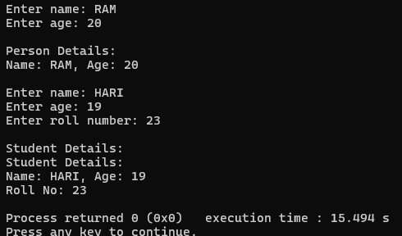

QN2. Implement a C++ program with a base class Account having a protected attribute balance. Derive a class SavingsAccount that adds an attribute interestRate and a function addInterest() to modify balance. Use user input to initialize attributes and show how the protected balance is accessed in the derived class but not outside.
#include<iostream>
using namespace std;
class Account{
protected:
float balance;
public:
Account(float b):balance(b){}
void display() const{
cout<<"balance is:"<<balance<<endl;
}};
class Savingaccount:public Account{
private:
float interestrate;
public:
Savingaccount(double b, double r) : Account(b), interestrate(r) {}
void addinterest() {
double interest = balance * (interestrate / 100);
balance += interest;
cout << "Interest of Rs" << interest << "." << endl;
}
void display() const {
cout << "Savings Account Details:" << endl;
Account::display();
cout << "Interest Rate: " << interestrate << "%" << endl;
}};
int main() {
double balance, interestrate;
cout << "Enter balance: Rs";
cin >> balance;
Account account(balance);
cout << "\nAccount Details:" << endl;
account.display();
cout << endl;
cout << "Enter balance: Rs";
cin >> balance;
cout << "Enter interest rate (%): ";
cin >> interestrate;
Savingaccount savings(balance, interestrate);
cout <<"Details Before Interest:" << endl;
savings.display();
cout << endl;
savings.addinterest();
cout << "Details After Interest:" << endl;
savings.display();
cout << endl;
return 0;
}
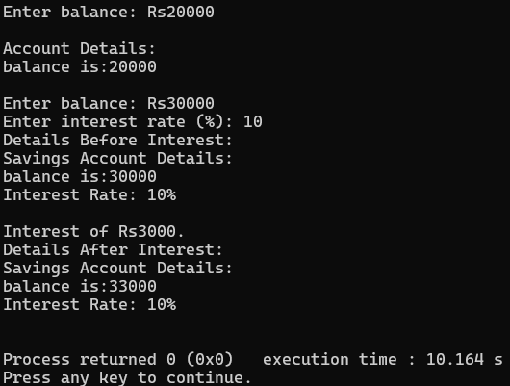
Q3. Write a C++ program with a base class Shape having a function draw(). Declare a derived class Circle with an attribute radius initialized via user input. Create a Circle object and call draw() to display a message including radius, demonstrating proper derived class declaration.#include<iostream>.
#include <iostream>
using namespace std;
class Shape {
public:
virtual void draw() const {
cout << "Drawing." << endl;
}};
class Circle : public Shape {
private:
double radius;
public:
Circle(double r) : radius(r) {}
void draw() const override {
cout << "Drawing Circle of radius: " << radius << endl;
}};
int main() {
double radius;
cout << "Enter radius: "<<endl;
cin >> radius;
Circle circle(radius);
cout << "Circle Details:" << endl;
circle.draw();
return 0;
}
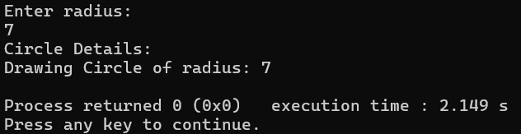
Q4. Create a C++ program with a base class Vehicle having a function move(). Derive a class Car that overrides move() to indicate driving. Use a base class pointer to call move() on a Car object initialized with user input for attributes like brand. Show that Car is a Vehicle.
#include<iostream>
using namespace std;
class Vehicle{
protected:
string brand;
public:
Vehicle(string b) : brand(b) {}
virtual void move() const {
cout << brand << "moves" << endl;
}
void display() const {
cout << "Brand: " << brand << endl;
}
};
class Car: public Vehicle{
public:
Car(string b) : Vehicle(b) {}
void move() const override {
cout << brand << " gudyoo." << endl;
}
};
int main() {
string brand;
cout << "Enter brand: ";
getline(cin, brand);
Car car(brand);
cout << "\nCar Details:" << endl;
car.display();

cout << endl;
Vehicle* vehiclePtr = &car;
vehiclePtr->move();
return 0;
}
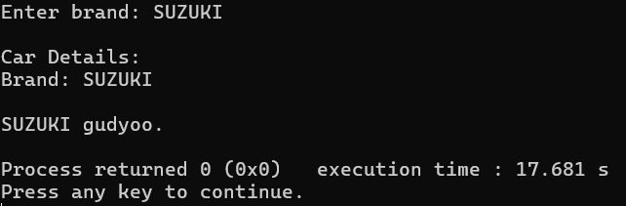

Q5. Implement a C++ program with a class Engine having an attribute horsepower. Create a class Car that contains an Engine object (composition) and an attribute model. Initialize all attributes with user input and display details to show that Car has an Engine.
#include<iostream>
using namespace std;
class Engine{
int horsepower;
public:
Engine(int hp) : horsepower(hp) {}
void display() const {
cout << "Engine Horsepower: " << horsepower << endl;
}
};
class Car {
private:
Engine engine;
string model;
public:
Car(int hp, string m) : engine(hp), model(m) {}
void display() const {
cout << "Car Details:" << endl;
cout << "Model: " << model << endl;
engine.display();
}
};
int main() {
string model;
int horsepower;
cout << "Enter car model: ";
getline(cin, model);
cout << "Enter engine horsepower: ";
cin >> horsepower;
cin.ignore();
Car car(horsepower, model);
cout << "\n";
car.display();
return 0;
}
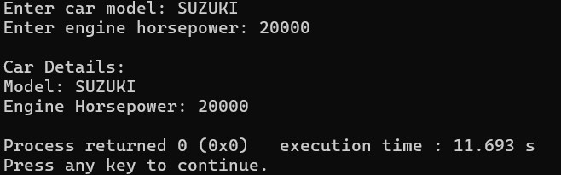
Q6. Write a C++ program with a base class Base having public, protected, and private attributes (e.g., pubVar, protVar, privVar). Derive three classes using public, protected, and private inheritance, respectively. Demonstrate with user-initialized objects how each inheritance type affects access to base class members.
#include <iostream>
#include <string>
using namespace std;
class Base {
public:
int pubVar;
protected:
int protVar;
private:
int privVar;
public:
Base(int pub, int prot, int priv) : pubVar(pub), protVar(prot), privVar(priv) {}
void display() const {
cout << "Base: Public Var = " << pubVar << ", Protected Var = " << protVar << ", Private Var = " <<
privVar << endl;
}};
class PublicDerived : public Base {
public:
PublicDerived(int pub, int prot, int priv) : Base(pub, prot, priv) {}
void display() const {
cout << "PublicDerived: Public Var = " << pubVar << ", Protected Var = " << protVar << endl;
}};
class ProtectedDerived : protected Base {
public:
ProtectedDerived(int pub, int prot, int priv) : Base(pub, prot, priv) {}
void display() const {
cout << "ProtectedDerived: Public Var = " << pubVar << ", Protected Var = " << protVar << endl;
}};
class PrivateDerived : private Base {
public:
PrivateDerived(int pub, int prot, int priv) : Base(pub, prot, priv) {}
void display() const {
cout << "PrivateDerived: Public Var = " << pubVar << ", Protected Var = " << protVar << endl;
}};
int main() {
int pub, prot, priv;
cout << "Creating Base object:" << endl;
cout << "Enter public variable: ";
cin >> pub;
cout << "Enter protected variable: ";
cin >> prot;
cout << "Enter private variable: ";
cin >> priv;
Base base(pub, prot, priv);
cout << "\nBase Object Details:" << endl;
base.display();
cout << "Accessing pubVar directly: " << base.pubVar << endl;
cout << endl;
cout << "Creating PublicDerived object:" << endl;
cout << "Enter public variable: ";
cin >> pub;
cout << "Enter protected variable: ";
cin >> prot;
cout << "Enter private variable: ";
cin >> priv;
PublicDerived pubDerived(pub, prot, priv);
cout << "\nPublicDerived Object Details:" << endl;
pubDerived.display();
cout << "Accessing pubVar directly: " << pubDerived.pubVar << endl;
cout << endl;
cout << "Creating ProtectedDerived object:" << endl;
cout << "Enter public variable: ";
cin >> pub;
cout << "Enter protected variable: ";
cin >> prot;
cout << "Enter private variable: ";
cin >> priv;
ProtectedDerived protDerived(pub, prot, priv);
cout << "\nProtectedDerived Object Details:" << endl;
protDerived.display();
cout << endl;
cout << "Enter public variable: ";
cin >> pub;
cout << "Enter protected variable: ";
cin >> prot;
cout << "Enter private variable: ";
cin >> priv;
PrivateDerived privDerived(pub, prot, priv);
cout << "\nPrivateDerived Object Details:" << endl;
privDerived.display();
return 0;
}
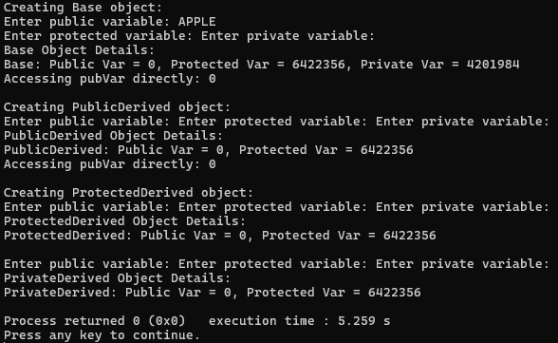
Q7. Create a C++ program with a base class Animal having a virtual function sound(). Derive classes Dog and Cat that override sound() to print specific sounds. Use a base class pointer array to call sound() on Dog and Cat objects created with user input, showing runtime polymorphism.
#include <iostream>
#include <string>
using namespace std;
class Animal {
protected:
string name;
public:
Animal(string n) : name(n) {}
virtual void sound() const {
cout << name << "animal sound." << endl;
}
void display() const {
cout << "Name: " << name << endl;
}};
class Dog : public Animal {
public:
Dog(string n) : Animal(n) {}
void sound() const override {
cout << name << " vau vau!" << endl;
}};
class Cat : public Animal {
public:
Cat(string n) : Animal(n) {}
void sound() const override {
cout << name << " meow meow" << endl;
}};
int main() {
string name;
Animal* animals[2];
cout << "Creating Dog object:" << endl;
cout << "Enter dog name: ";
getline(cin, name);
animals[0] = new Dog(name);
cout << "\nCreating Cat object:" << endl;
cout << "Enter cat name: ";
getline(cin, name);
animals[1] = new Cat(name);
cout << "\nAnimal Details and Sounds:" << endl;
for (int i = 0; i < 2; i++) {
animals[i]->display();
animals[i]->sound();
cout << endl;
}
for (int i = 0; i < 2; i++) {
delete animals[i];
}
return 0;
}
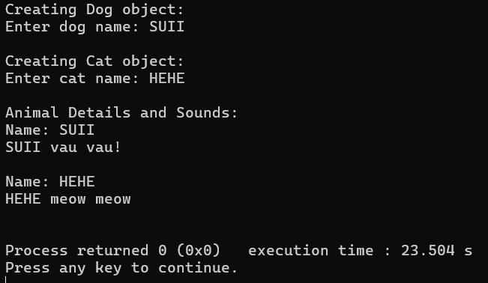
Q8. Write a C++ program with two base classes Battery and Screen, each with a function showStatus(). Derive a class Smartphone that inherits from both. Resolve ambiguity when calling showStatus() using the scope resolution operator. Initialize attributes with user input and display details.
#include <iostream>
#include <string>
using namespace std;
class Battery {
protected:
int capacity;
public:
Battery(int cap) : capacity(cap) {}
void showStatus() const {
cout << "Battery Status: " << capacity << " mAh" << endl;
}};
class Screen {
protected:
double size;
public:
Screen(double s) : size(s) {}
void showStatus() const {
cout << "Screen Status: " << size << " inches" << endl;
}};
class Smartphone : public Battery, public Screen {
private:
string model;
public:
Smartphone(int cap, double s, string m) : Battery(cap), Screen(s), model(m) {}
void display() const {
cout << "Smartphone Details:" << endl;
cout << "Model: " << model << endl;
Battery::showStatus();
Screen::showStatus();
}};
int main() {
string model;
int capacity;
double size;
cout << "Creating Smartphone object:" << endl;
cout << "Enter model: ";
getline(cin, model);
cout << "Enter battery capacity : ";
cin >> capacity;
cout << "Enter screen size (inches): ";
cin >> size;
cin.ignore();
Smartphone phone(capacity, size, model);
cout << "\n";
phone.display();
return 0;
}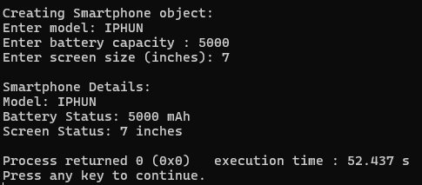

Q9. Implement a C++ program with a base class Person having a parameterized constructor for name and age. Derive a class Employee with an additional attribute employeeID. Use user input to initialize all attributes and show the order of constructor invocation when creating an Employee object.
#include <iostream>
#include <string>
using namespace std;
class Person {
protected:
string name;
int age;
public:
Person(string n, int a) : name(n), age(a) {
cout << "Person constructor called: Name = " << name << ", Age = " << age << endl;
}
void display() const {
cout << "Name: " << name << ", Age: " << age << endl;
}
};
class Employee : public Person {
private:
string employeeID;
public:
Employee(string n, int a, string id) : Person(n, a), employeeID(id) {
cout << "Employee constructor called: EmployeeID = " << employeeID << endl;
}
void display() const {
cout << "Employee Details:" << endl;
Person::display();
cout << "Employee ID: " << employeeID << endl;
}};
int main() {
string name, employeeID;
int age;
cout << "Creating Employee object:" << endl;
cout << "Enter name: ";
getline(cin, name);
cout << "Enter age: ";
cin >> age;
cin.ignore(); //
cout << "Enter employee ID: ";
getline(cin, employeeID);
cout << "\nConstructor Invocation Order:" << endl;
Employee employee(name, age, employeeID);
cout << "\n";
employee.display();
return 0;
}
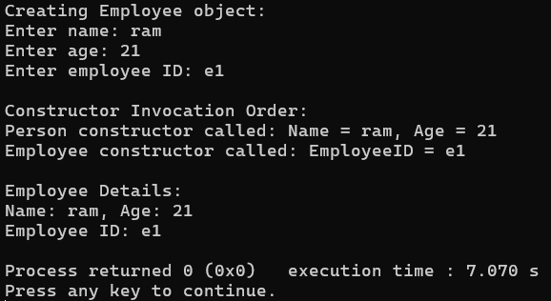
Q10. Write a C++ program with a base class Shape and a derived class Rectangle, both with destructors that print messages. Make the base class destructor virtual. Create a Rectangle object through a base class pointer using user input for attributes, and delete it to show proper destructor invocation. Compare with a non-virtual destructor case.
#include <iostream>
using namespace std;
class Shape {
protected:
double width;
public:
Shape(double w) : width(w) {
cout << "Shape constructor called: Width = " << width << endl;
}
virtual ~Shape() {
cout << "Shape destructor called" << endl;
}
void display() const {
cout << "Shape Width: " << width << endl;
}};
class Rectangle : public Shape {
private:
double height;
public:
Rectangle(double w, double h) : Shape(w), height(h) {
cout << "Rectangle constructor called: Height = " << height << endl;
}
~Rectangle() {
cout << "Rectangle destructor called" << endl;
}
void display() const {
cout << "Rectangle Details:" << endl;
Shape::display();
cout << "Height: " << height << endl;
}};
int main() {
double width, height;
cout << "Creating Rectangle object via base class pointer:" << endl;
cout << "Enter width: ";
cin >> width;
cout << "Enter height: ";
cin >> height;
Shape* shapePtr = new Rectangle(width, height);
cout << "\n";
shapePtr->display();
cout << "\nDeleting Rectangle object via base class pointer:" << endl;
delete shapePtr;
return 0;
}
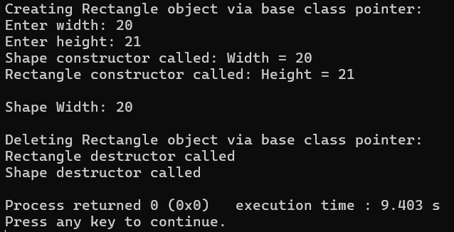
Q11. Create a C++ program with a base class A having an attribute value. Derive classes B and C from A, and derive class D from both B and C. Use virtual inheritance to avoid duplication of A’s members. Initialize value with user input and display it from D to show ambiguity resolution.
#include <iostream>
using namespace std;
class A {
protected:
int value;
public:
void setValue(int v) {
value = v;
}
void showValue() {
cout << "Value from class A: " << value << endl;
}};
class B : virtual public A {
};
class C : virtual public A {
};
class D : public B, public C {
public:
void display() {
showValue();
}};
int main() {
D obj;
int input;
cout << "Enter a value: ";
cin >> input;
obj.setValue(input);
obj.display();
return 0;
}
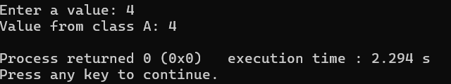

DISCUSSIONS
In this lab session, we discussed about the concepts of inheritance. We created base class and observed how the properties of this class is inherited by the derived classes. We discussed different types of inheritance such as public, protected, and private. We also learnt about the IS-A relationship and HAS-A relationship and their advantages in the programming. Moreover, we used the member override function by using override and virtual keywords.

CONCLUSIONS
In this lab session we learned how derived classes can inherit properties and behaviors from base classes, promoting code reusability and hierarchical organization. The session also highlighted the use of access specifiers, IS-A and HAS-A relationships, and the importance of function overriding for achieving runtime polymorphism.

